1. Sign up an account in 🡪 <https://www.mongodb.com/cloud/atlas/lp/try2-in?utm_source=google&utm_campaign=gs_apac_india_search_core_brand_atlas_desktop&utm_term=mongodb%20atlas&utm_medium=cpc_paid_search&utm_ad=e&utm_ad_campaign_id=12212624347>
2. 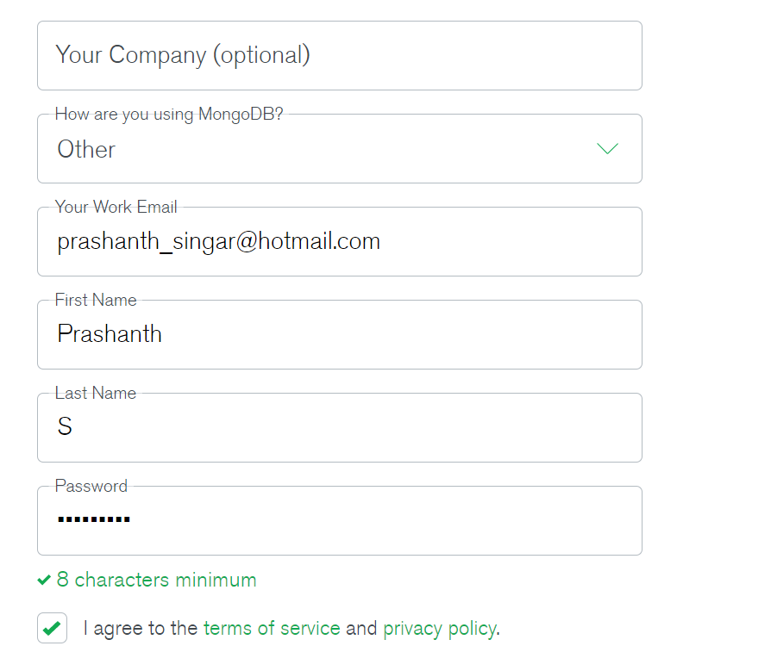
3. Create a Project

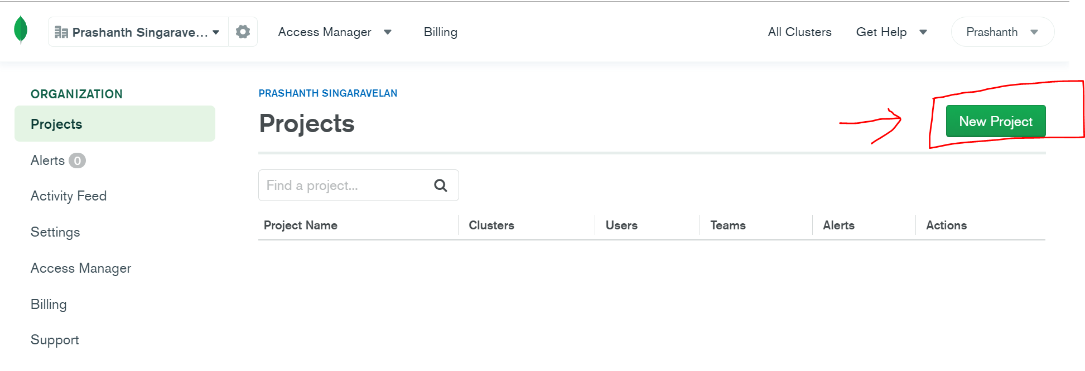

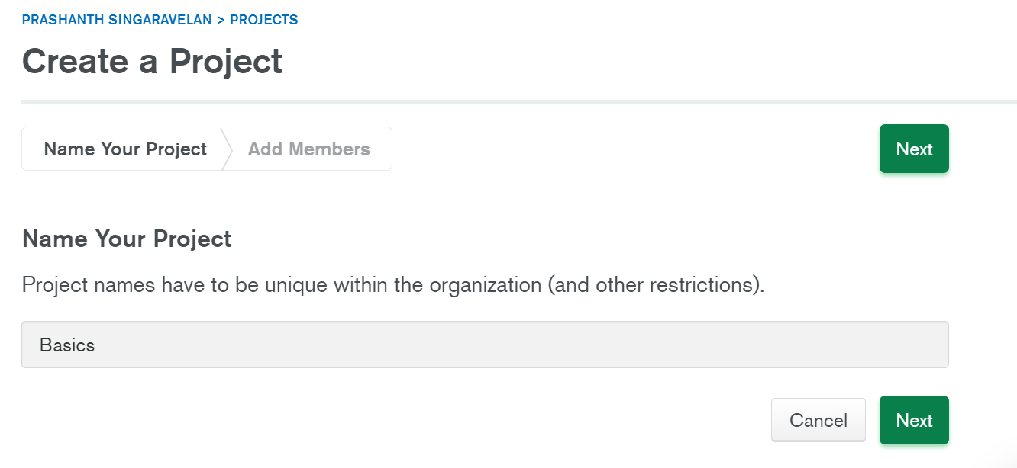  
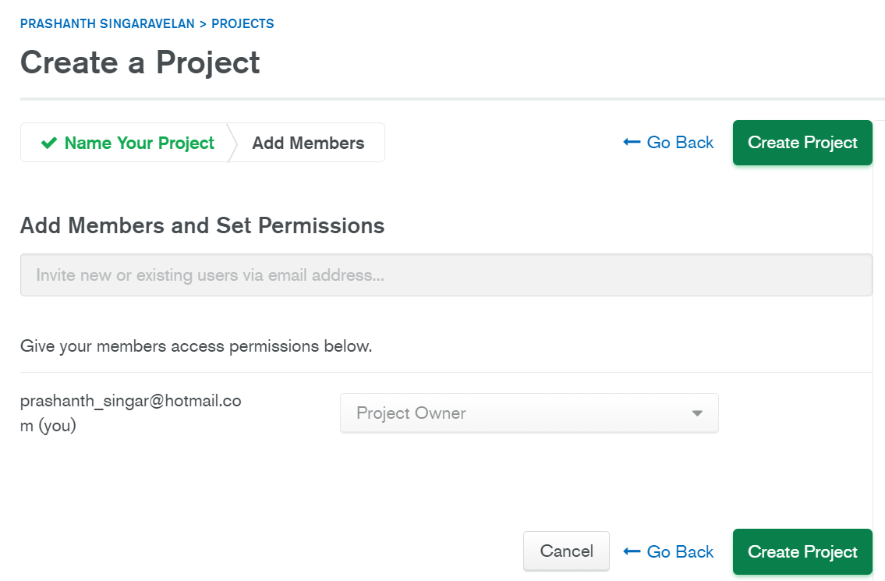

1. Create a cluster  
   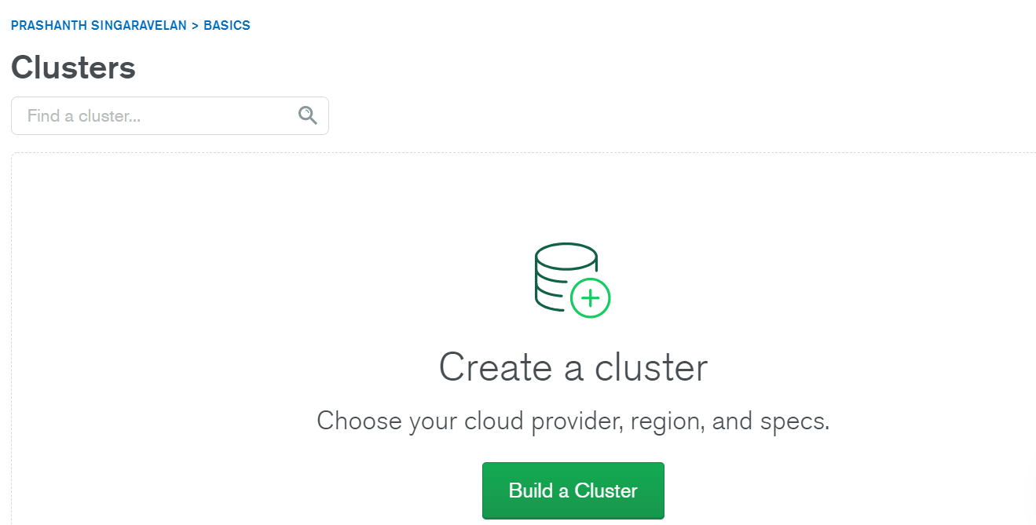

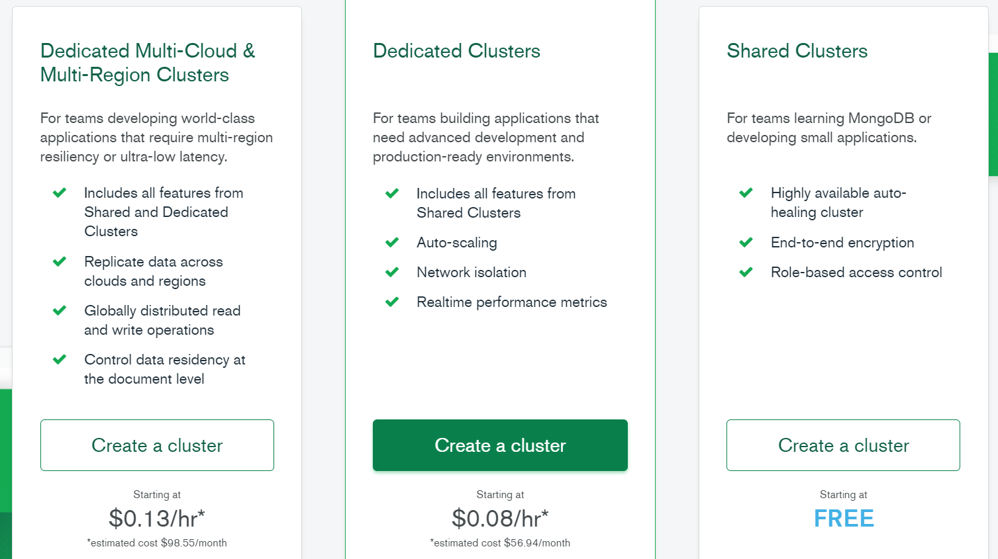

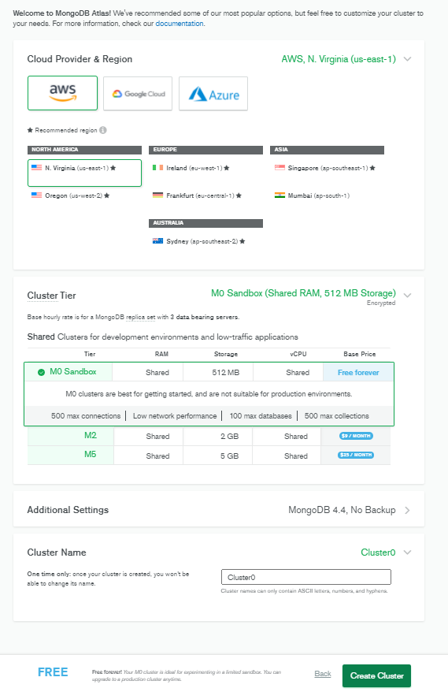

**Install MongoDB on Windows**  
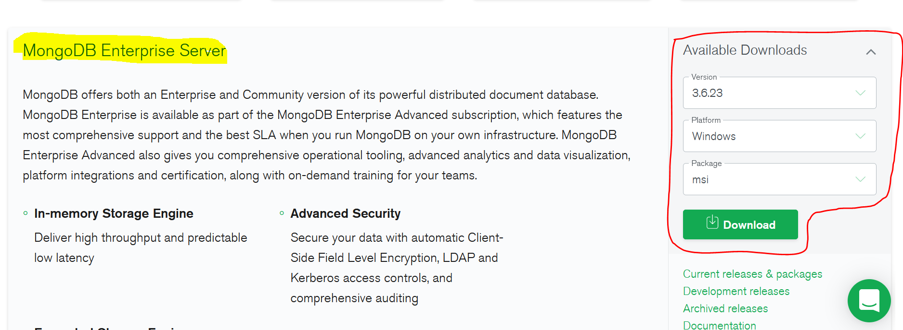  
<https://www.mongodb.com/try/download/enterprise>

## **Adding it to the environment variable**

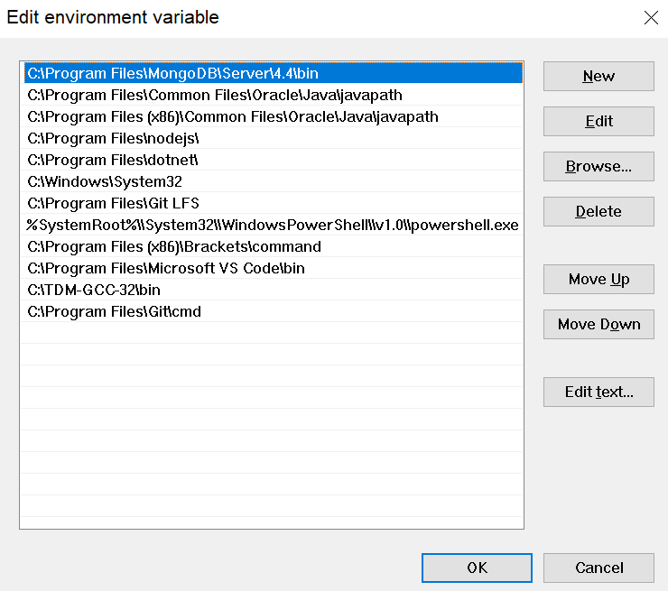

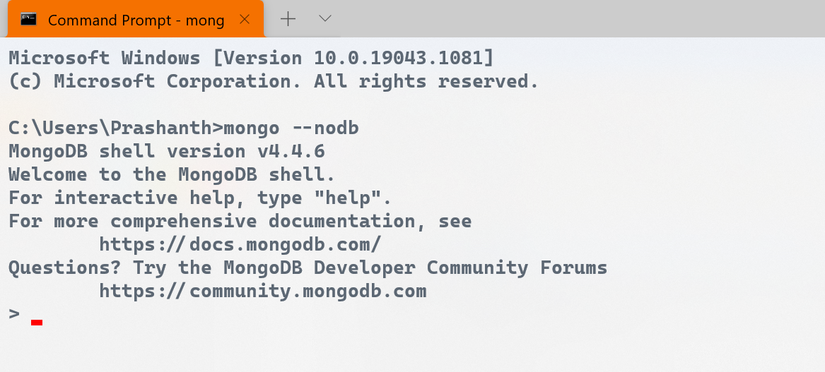

Creating a conda environment

